This is the report for your new business growth opportunity. As a consultant, I analyzed the survey conducted by you and find one opportunity you can implement.

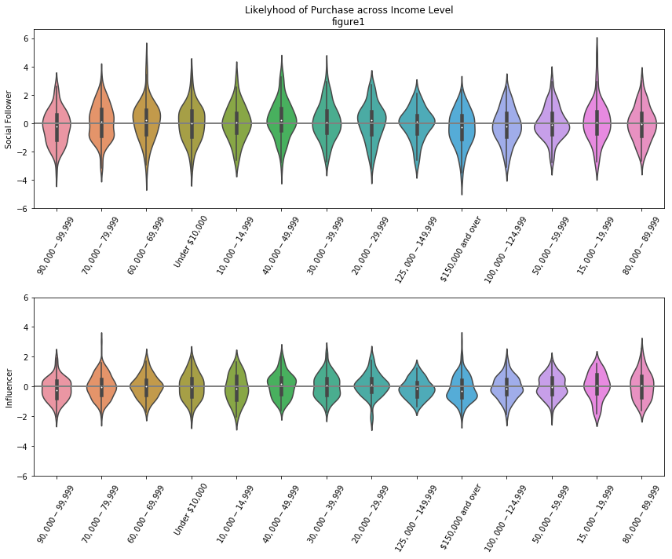 I found two groups of people in your survey claim they enjoy purchasing new gadgets and appliances. Meanwhile, they don’t really into luxury brands. This can be an opportunity that help them find the makers who offer nice design, reliable performance, and relatively low price. The two customers segments live in different live-style. I call the first group as social follower. They use social networking apps and they like to follower the opinion leaders. The second group is the influencer. They are more likely to try new apps and lead the decision-making process. The life-styles of the two group are total conflict with each other, but we can use them together. the strategy is sample. Collaborating with influencers and using their influence power to target social followers.

We should only target on one range of income group as a brokn point. Influencers from income levels of 20,000 to 29,999 and 40,000 to 49,999 are more likely to purchase apps; meanwhile, social followers are more separate out. They from income levels of 40,000 to 49,999, 60,000 to 69,999, and 125,000 to 149,999 (figure 1). One thing needs to mention is customers from 40,000 to 49,999 from of both groups are more likely to purchase. We can work with influencers from 20,000 to 29,999 range by sending out free items or give out some commissions, since their income is not high, they would happy to collaborate. The monkey generators are the people from higher income levels.

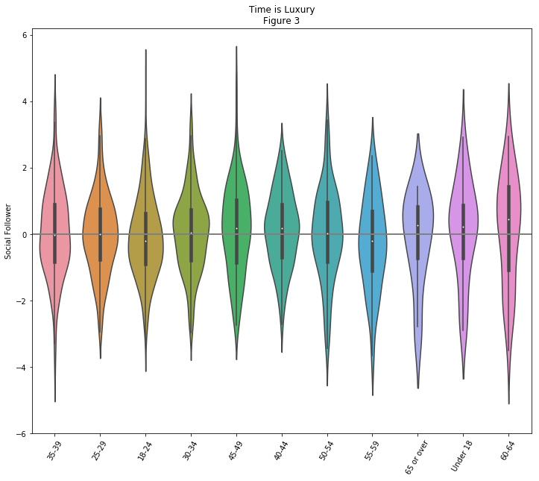 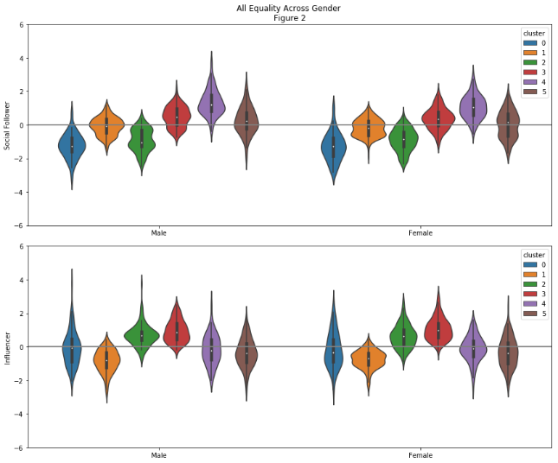 It’s not feasible to reach every customer segment within the target income level considering investments and returns. As shown in figure 2, gender doesn’t make any difference, so we should target on both male and female. However, only cluster 3 and 4 from social followers and cluster 2 and 3 from influencers are outperform than other clusters. Taking our collaborating strategy in concern, we should build up partner relationship with cluster 2 from influencers and target on 3 and 4 from social followers and cluster 3 from influencers.

Gadgets and appliances are the toys for someone has leisure time. It’s not a supervise that both teenagers and older people are more likely to buy them (figure 3). But considering older people is normally not familiar with new technology, we should only target on youths and people whose age range from 40 to 49. And encourage them buy gadgets and appliances from us as a gift for the elders at their family.

In summary, we can partner with influencers from cluster 2 with income from 20,000 to 29,999 to target social followers, who is middle age and come from cluster 3 and 4 with income among 40,000 to 49,999, 60,000 to 69,999, and 125,000 to 149,999.